 

**EXPERIMENT REPORT OF ASSEMBLY LANGUAGE**

Assignment 1 Experiment 2

NAME : ABID ALI

STUDENT ID :2019380141

DATE : 5/22/2021

SUBMITTED TO :PROFESSOR Yin LU

**Problem Description:**

**Chapter 3 Experiment 2 Simple IO and Lantern Control**

We will start from a virtual device provided by the emu8086. Then move to the Proteus and try to run some program on the virtual hardware circuit.

(1)Output a data to a typical device port.

The emu8086 provides a virtual led display device, which is emulated by a program called “led_display.exe”. The virtual device can display decimal number up to 5 digits.

By output a word type data to port 199, which is a word sized IO port addres, you can change the display to the number you output. Now write a program to display numbers from 0 to 65535 in a loop.

Each time you write a number to the port, remember to call a sub program called “delay”, so that to wait for the display to be stable.

The template of the program is provided by teacher

#start=led_display.exe#

.MODEL SMALL

.STACK 64

.DATA

PORT_LED EQU 199

.CODE

MAIN PROC FAR;this is the program entry point

MOV AX, @DATA ;load the data segment address

MOV DS, AX ;assign value to data segment register

;TODO1: display 8888 to test the device

MOV AX, 8888

MOV DX, PORT_LED

OUT DX, AX

CALL DELAY ;call delay sub procedure

;TODO2: start to display numbers

;(put your program to do the display of numbers here)

MOV AH, 4CH ;set up to

INT 21H ;return to DOS

MAIN ENDP

;===========================================================

DELAY PROC NEAR

PUSH BX;

PUSH CX;

MOV BX,0Ah loop_OUT: MOV CX, 03h

loop_inner: LOOP loop_inner

DEC BX

JNZ loop_OUT

POP CX;

POP BX;

RET

DELAY ENDP

END MAIN ;this is the program exit point

**Goal:**

We are going to make a virtual device provided by the emu8086.Try to work with peripheral device.The virtual device can display can show up to 5 digits.

We use a word type to port 199 this is the IO address .

Each time we write a number to the port then a sub program is called “delay”,we need to wait for the display to be stable.

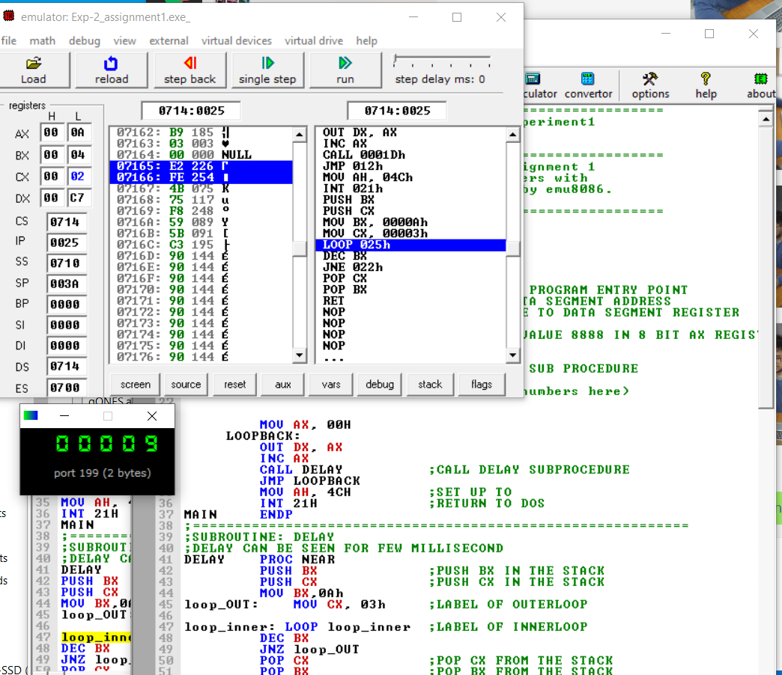

**Code:**

;========================================================

;Description: Program of Assignment 1 Experiment2

;Author:[ABID ALI][2019380141]

;Date:[05/17/2021]

;========================================================

;This is the program for experiment2 assignment 1

;In this program, we try to display numbers with

; a virtual led display device provided by emu8086.

;The port to setup the display is 199

;========================================================

#start=led_display.exe#

.MODEL SMALL

.STACK 64

.DATA

PORT_LED EQU 199

.CODE

MAIN PROC FAR ;THIS IS THE PROGRAM ENTRY POINT

MOV AX, @DATA ;LOAD THE DATA SEGMENT ADDRESS

MOV DS, AX ;ASSIGN VALUE TO DATA SEGMENT REGISTER

;TODO1: DISPLAY 8888 TO TEST THE DEVICE

MOV AX, 8888 ;MOVING THE VALUE 8888 IN 8 BIT AX REGISTER

MOV DX, PORT_LED

OUT DX, AX

CALL DELAY ;CALL DELAY SUB PROCEDURE

;TODO2: START TO DISPLAY NUMBERS

;(put your program to do the display of numbers here)

MOV AX, 00H

LOOPBACK:

OUT DX, AX

INC AX

CALL DELAY ;CALL DELAY SUBPROCEDURE

JMP LOOPBACK

MOV AH, 4CH ;SET UP TO

INT 21H ;RETURN TO DOS

MAIN ENDP

;===========================================================

;SUBROUTINE: DELAY

;DELAY CAN BE SEEN FOR FEW MILLISECOND

DELAY PROC NEAR

PUSH BX ;PUSH BX IN THE STACK

PUSH CX ;PUSH CX IN THE STACK

MOV BX,0Ah

loop_OUT: MOV CX, 03h ;LABEL OF OUTERLOOP

loop_inner: LOOP loop_inner ;LABEL OF INNERLOOP

DEC BX

JNZ loop_OUT

POP CX ;POP CX FROM THE STACK

POP BX ;POP BX FROM THE STACK

RET

DELAY ENDP

END MAIN ;THIS IS THE PROGRAM EXIT POINT

**Debugging:**

This is a new IDE for me ,I have never used it before .So,at the beginning ,I couldn’t understand the use of so many features.Eventually,after watching video.

**Attachment:**

1) Experiment-2(assignment-1).mkv

2) Exp-2_ assignment1.asm

3) Exp-2_ assignment1.pdf

**Acknowledgement:**

I complete this assignment by myself by using online videos and taking help from online.The most useful help from teacher’s hint given in question ,the theory class and the lecture note from the practical class